Tugas Section 8 bagian: HTTP Method GET

Code Automation yang di jalankan di dua tools (postman & cypress)

Postman

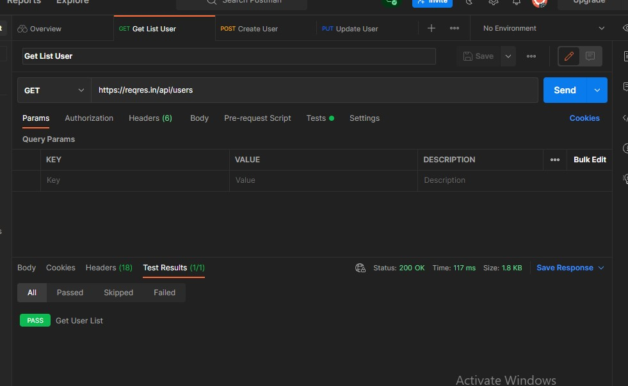

Cypress

